***Name : shaikh Zakariya  
Roll No :- 820  
Class:- Sybms***

***Topic : “Understanding Consumer Behavior Towards Garnier Face Wash: A Survey Analysis****”* ***Introduction:  
  
Consumer behavior plays a crucial role in shaping the success of any product or brand. In the competitive world of skincare products, it is essential for companies like Garnier to gain insights into how consumers perceive and interact with their products, such as face wash. To this end, we conducted a survey to explore various aspects of consumer behavior related to Garnier Face Wash.***

**AGE WISE**  
**This demographic information will help us understand the age group of our respondents,**

**allowing for age-specific insights**  
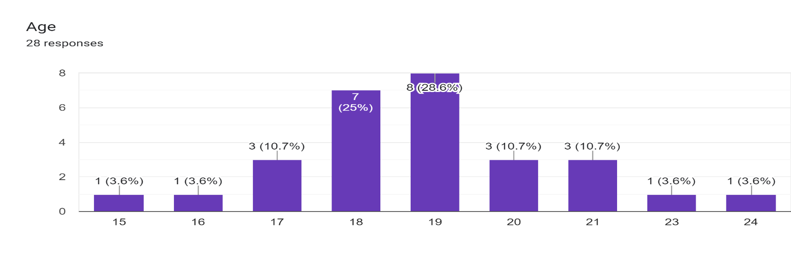  
**In accordance with the supplied data, the following is an overview of the distribution of respondents' ages:**

1. A mere 3.6% of respondents fall within the age group of 15 and 16 years old.

2. A substantial 10.7% of the respondents belong to the age category of 17 years old.

3. A quarter of the respondents, constituting 25%, are 18 years old.

4. The largest age group among the respondents is 19 years old, accounting for 28.6%.

5. Another 10.7% of respondents are aged between 20 and 21 years.

6. Lastly, 3.6% of the respondents fall into the age bracket of 22, 23, and 24 years old.

**How long have you been using our product?**

**This question assesses customer loyalty and the longevity of their relationship**

**with Garnier Face Wash.**

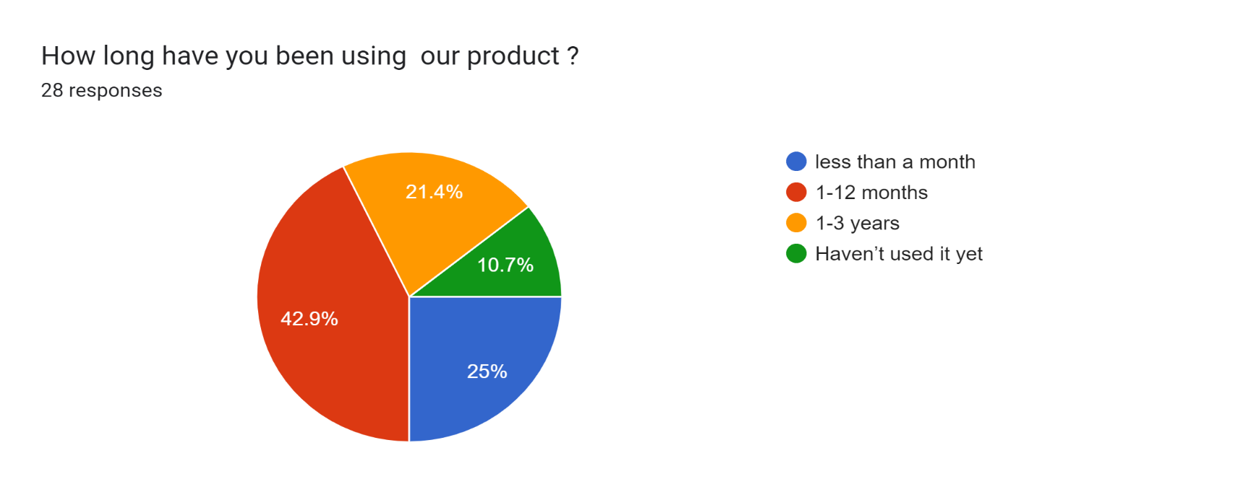

**Here's a simplified report with 10 bullet points on the topic of "How long have you been using our product”**

1. A significant portion of users, comprising 42.9%, have been using our product for a duration ranging from 1 to 12 months.

2. The second-largest group consists of 25% of respondents who have been using the product for less than a month.

3. About 21.4% of users have been loyal customers, using our product for 1 to 3 years.

4. Interestingly, 10.7% of the respondents haven't used our product at all.

5. The data suggests that the majority of respondents fall within the 1 to 12 months category of product usage.

6. The second most common usage duration is less than a month, with a quarter of respondents falling into this category.

7. A notable proportion of users, approximately 21.4%, have maintained their product usage for 1 to 3 years, indicating long-term satisfaction.

8. On the flip side, there is a small but noteworthy 10.7% of respondents who haven't tried our product yet.

9. It is clear from the data that the majority of users are relatively new to our product, using it for less than a year.

10. This information can guide our marketing and customer engagement strategies to better cater to the various segments of our user base, from newcomers to long-standing customers.

**How often do you use our product?**

**Frequency of product usage can provide valuable information on usage patterns**

**and product satisfaction.**

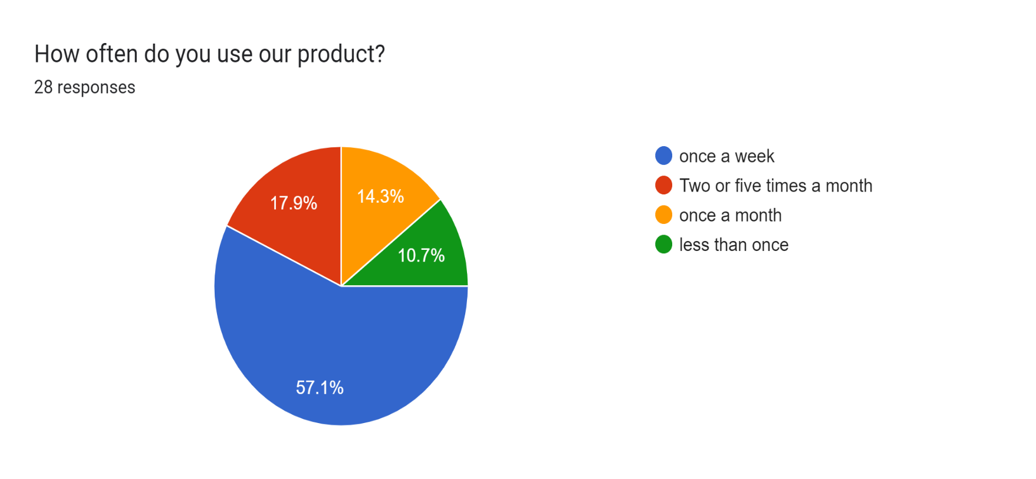

**Here's a detailed report with 10 bullet points on the topic of "How often do you use our product?"**

1. The majority of users, constituting 57.1%, reported using our product once a week, indicating a high frequency of usage among this group.

2. The second most common usage frequency is between two to five times a month, with 17.9% of respondents falling into this category.

3. About 14.3% of users use our product once a month, demonstrating a consistent but less frequent usage pattern.

4. Interestingly, 10.7% of the respondents reported using our product less than once, suggesting infrequent or sporadic usage.

5. The data clearly shows that a significant portion of respondents prefers to use our product on a weekly basis.

6. The second-largest group includes those who use the product two to five times a month, comprising 17.9% of the respondents.

7. A smaller but still noteworthy percentage, 14.3%, uses our product once a month, indicating a monthly routine.

8. On the opposite end of the spectrum, there is a group of 10.7% who use our product very infrequently, less than once.

9. Understanding these usage patterns can help us tailor our marketing strategies and product enhancements to cater to the

needs and preferences of different user segments.

10. Overall, the data reflects diverse usage frequencies among our user base, highlighting the importance of accommodating varying

usage habits to maintain and expand our user engagement.

**How satisfied are you with the product?**

**This helps gauge overall customer satisfaction, which is a critical**

**indicator of product success**

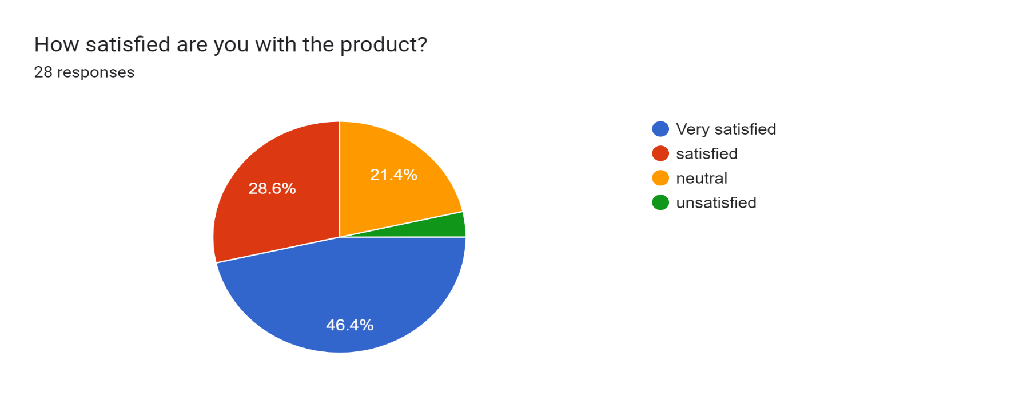

**Here's a comprehensive report with 10 bullet points on the topic of "How satisfied are you with the product?"**

1. The largest segment of respondents, comprising 46.4%, expressed that they are "Very satisfied" with our product. This indicates a high level of overall satisfaction among this group.

2. Following closely, 28.6% of respondents reported being "Only satisfied" with the product, signifying a significant proportion of satisfied users.

3. A substantial 21.4% of respondents indicated a "Neutral" level of satisfaction, suggesting that they neither strongly endorse nor criticize the product.

4. A smaller portion, 3.6% of respondents, expressed being "Unsatisfied" with the product, indicating room for improvement in addressing their concerns.

5. It is evident that the majority of respondents hold a positive view of our product, with "Very satisfied" being the predominant sentiment.

6. The second-largest group, "Only satisfied," also represents a considerable share of respondents, indicating a solid user base that is content with the product.

7. The "Neutral" category represents those users who may have mixed feelings or have not formed a strong opinion about the product.

8. While a relatively small percentage reported being "Unsatisfied," it is important to address their concerns and explore ways to enhance their experience.

9. The data underscores the importance of maintaining high levels of user satisfaction while actively engaging with those in the "Neutral" and "Unsatisfied" categories to improve their perception.

10. Overall, this information provides valuable insights into the satisfaction levels of our user base and can guide efforts to continuously improve our product and enhance user experiences.

**Would you use our product in the future?**

**Future usage intentions can provide insights into brand loyalty and potential repeat purchases**

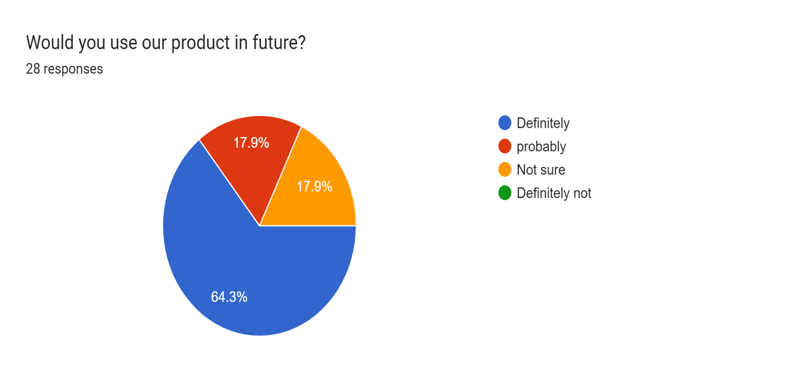

**Here's an in-depth report with 10 bullet points on the topic of "Would you use our product in the future?"**

1. The majority of respondents, totaling 64.3%, expressed a strong inclination to "Definitely use" our product in the future. This signifies a high level of confidence and intent among this group to continue using our product.

2. A significant portion, comprising 17.9% of respondents, indicated they would "Probably use" our product in the future.

This suggests a substantial contingent of potential future users.

3. Another 17.9% of respondents fell into the category of "Not Sure" about using our product in the future. This group is uncertain about their future usage intentions, indicating a need for further engagement and clarification.

4. The data underscores the positive sentiment among the majority of respondents, who are eager to continue using our product.

5. The combined percentage of those who are "Probably use" and "Not Sure" about our product's future usage stands at 35.8%. This is a significant segment that requires attention to address any doubts and convert potential users into confident ones.

6. Understanding the reasons behind the uncertainty among the "Not Sure" group is crucial to address any concerns they may have and facilitate a more informed decision-making process.

7. The high percentage (64.3%) of respondents who "Definitely use" our product in the future is a promising indicator of brand loyalty and satisfaction.

8. To maximize future usage, it's essential to engage with the "Probably use" group and provide them with compelling reasons to choose our product.

9. Strategies for providing more information and support to the "Not Sure" group can help convert them into confident future users.

10. Overall, this data provides valuable insights into the future potential of our product and highlights opportunities for engagement and improvement in order to secure a strong user base moving forward.

**Are you more likely to purchase from a brand you've used before?**

**This question explores the impact of brand familiarity on consumer purchasing decisions.**

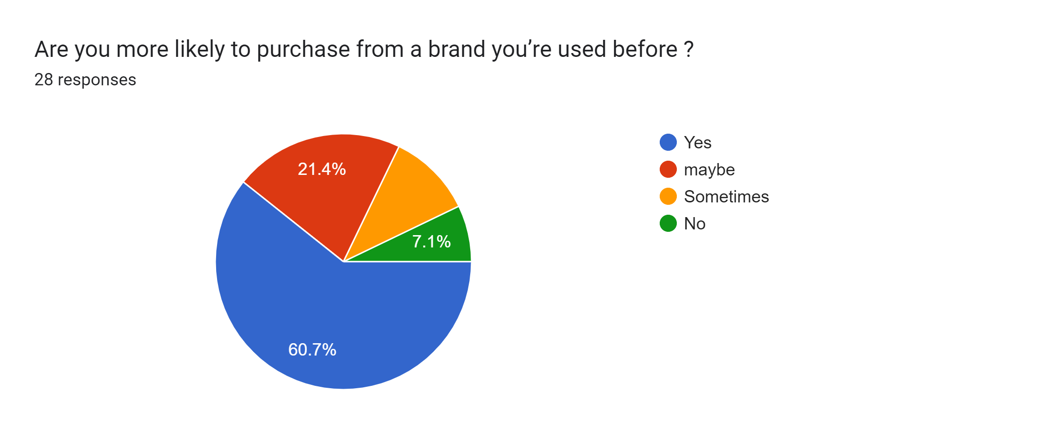

Here's a comprehensive report with 10 bullet points on the topic of "Are you more likely to purchase from a brand you've used before?" based on the provided data:

1. The majority of respondents, accounting for 60.7%, indicated that they are highly inclined to repurchase from a brand they've used before, categorically responding with "Yes." This demonstrates a strong level of brand loyalty and satisfaction.

2. Following closely, 21.4% of respondents expressed a level of uncertainty, responding with "Maybe" when considering repurchasing from a familiar brand. This group represents a significant portion of potential repeat customers.

3. Approximately 10.7% of respondents fell into the category of "Sometimes," suggesting that their likelihood of repurchasing from a previously used brand varies. This group may require further understanding of their specific purchasing patterns.

4. A minority, 7.1% of respondents, responded with "Not" likely to repurchase from a brand they've used before. This group presents an opportunity for brands to identify and address any issues that may deter repeat purchases.

5. The data underscores the importance of fostering brand loyalty and delivering exceptional experiences to encourage the majority of respondents who are inclined to repurchase ("Yes").

6. The "Maybe" category represents a substantial segment that may require targeted marketing efforts or incentives to convert them into loyal customers.

7. Understanding the "Sometimes" group is vital, as it indicates that purchasing behavior might be influenced by various factors that brands can explore and address.

8. For the "Not" likely group, it is essential to investigate the reasons behind their hesitance to repurchase and work on improving their overall experience.

9. Brands should focus on strategies that emphasize consistent quality, outstanding customer service, and personalized engagement to nurture brand loyalty.

10. In conclusion, this data provides valuable insights into customer purchasing behavior and highlights opportunities for brands to build and maintain strong relationships with their customer base through effective retention strategies.

**What makes you loyal to a particular brand product?**

**Understanding factors that drive brand loyalty can help Garnier improve its products and marketing strategies.**

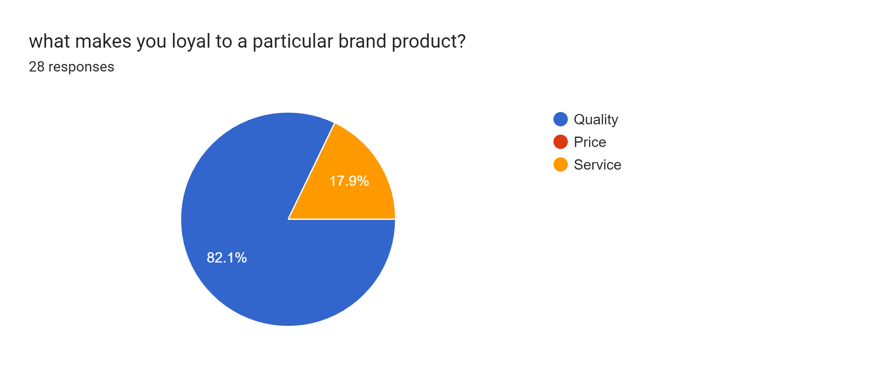

**Here's a detailed report with 10 bullet points on the topic of "What makes you loyal to a particular brand product?"**

1. The majority of respondents, comprising a substantial 82.1%, cited "Quality" as the primary factor that fosters brand loyalty. This highlights the paramount importance of product quality in retaining customers.

2. A smaller but significant portion, 17.9% of respondents, reported being loyal to a brand based on "Service." This suggests that exceptional customer service can also play a crucial role in building and maintaining brand loyalty.

3. Interestingly, there is no record of loyalty being primarily based on "Price." This may indicate that for this particular group of respondents, factors other than price, such as quality and service, are more influential in brand loyalty.

4. The data underscores the critical role of product quality in building trust and loyalty among customers.

5. The "Service" category represents a substantial segment of customers who value the overall experience and support they receive from a brand.

6. The absence of loyalty based on "Price" suggests that customers may prioritize value and overall satisfaction over seeking the lowest price point.

7. Brands should recognize the importance of delivering consistent quality and exceptional service to maintain and grow their loyal customer base.

8. Understanding the factors that drive loyalty can help brands tailor their strategies and offerings to meet customer expectations.

9. Brands that prioritize both product quality and service excellence are likely to enjoy higher levels of customer loyalty and advocacy.

10. In conclusion, this data provides valuable insights into the key drivers of brand loyalty, emphasizing the pivotal role of quality and the significance of service in creating and nurturing long-term customer relationship

**Have you ever switched from a particular brand product ?**

**Switching behaviour can reveal why customers transition from one brand to another.**

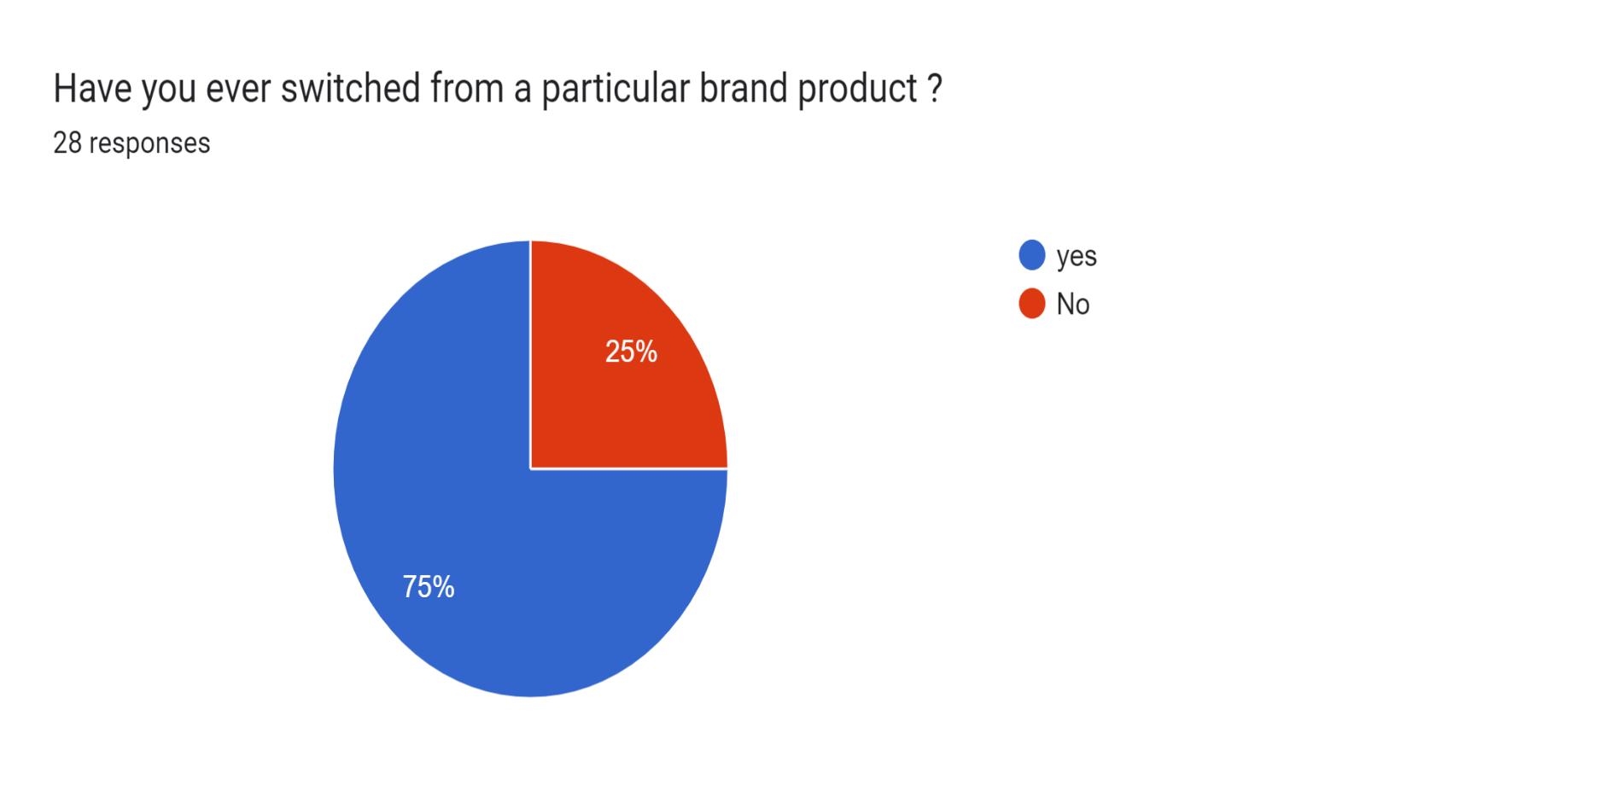

**Here's a comprehensive report with 10 bullet points on the topic of "Have you ever switched from a particular brand product?" based on the provided data:**

1. The majority of respondents, representing a substantial 75%, reported that they have indeed "switched" from a particular brand product at some point in their consumer journey.

2. In contrast, a smaller but significant segment, totaling 25% of respondents, indicated that they have "never switched" from a particular brand product, demonstrating a high degree of brand loyalty.

3. The data underscores that a substantial portion of consumers has experienced the process of switching from one brand product to another.

4. The "Never switched" group suggests a level of steadfast loyalty to a specific brand, which may be attributed to consistently positive experiences or strong brand affinity.

5. The "Switched" category reflects a dynamic consumer landscape where factors like product performance, innovation, or changing preferences influence purchasing decisions.

6. Understanding the reasons behind switching behavior is crucial for brands seeking to retain customers and attract new ones.

7. Brands should consider strategies to both retain loyal customers and entice those who have switched in the past.

8. For those who have never switched, it is essential to maintain the quality and value that have earned their loyalty.

9. Brands should also adapt and innovate to meet the changing needs and preferences of consumers who have experienced switching.

10. In conclusion, this data provides valuable insights into consumer behavior regarding brand switching, highlighting the significance of both brand loyalty and the potential for consumers to explore new products and brands over time.

**What impressed you more about the product?**

**This open-ended question allows respondents to share their positive experiences**

**and key product attributes.**

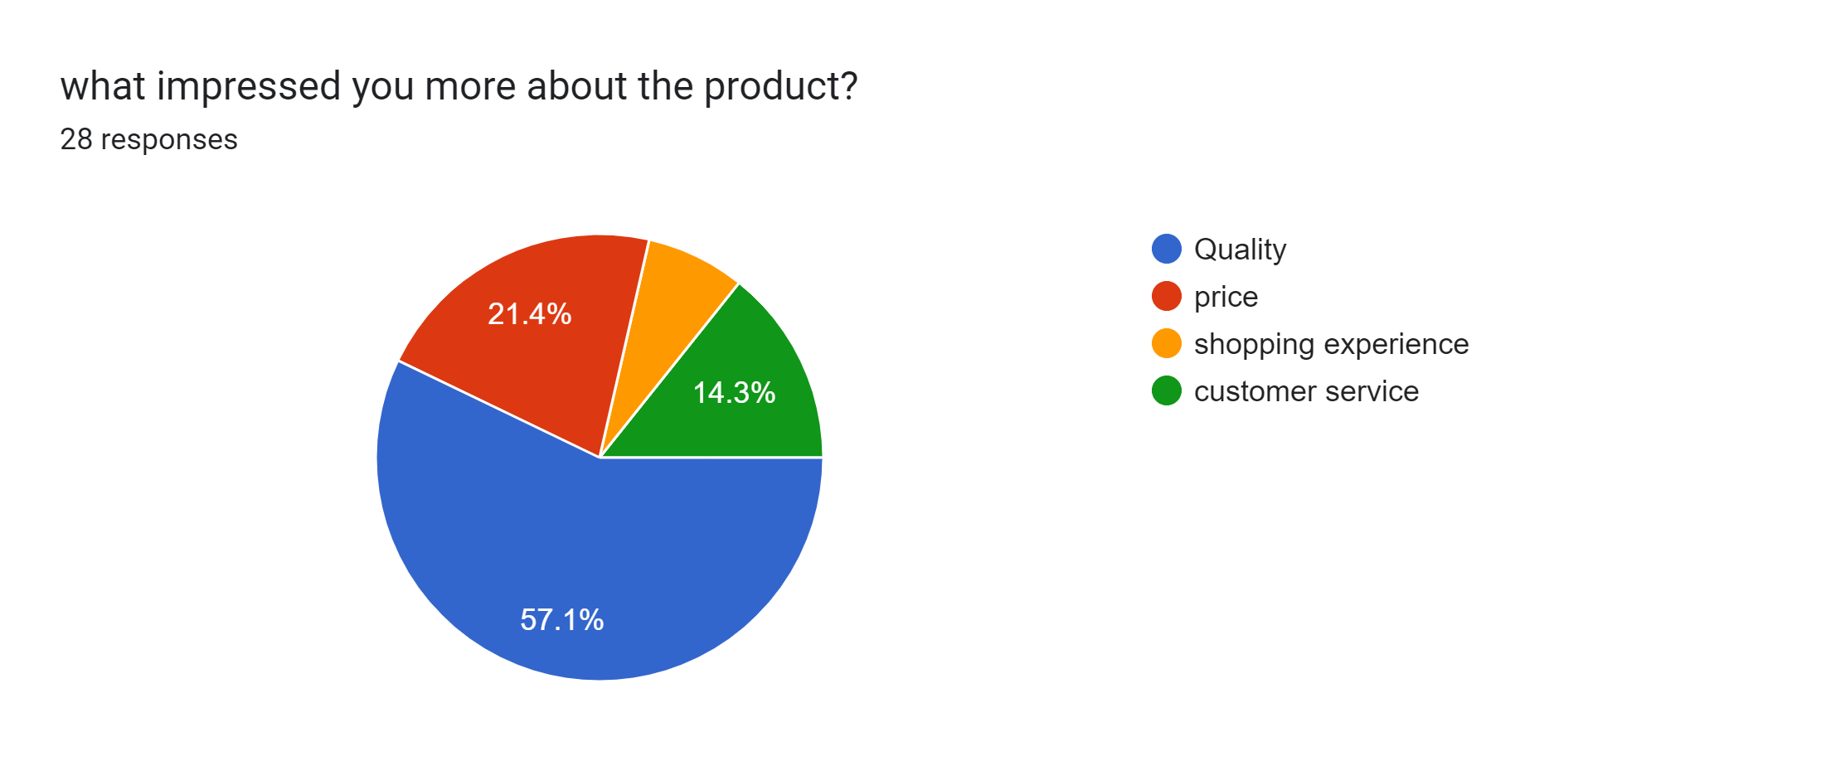

**Here's a detailed report with 10 bullet points on the topic of "What impressed you more about the product?"**

1. The data reveals that the majority of respondents, a significant 57.1%, were most impressed by the "Quality" of the product. This highlights the paramount importance of product quality in consumer perceptions.

2. Following quality, "Price" emerged as the next most crucial factor, with 21.4% of respondents considering it impressive. Price sensitivity remains a significant influence on consumer decision-making.

3. "Customer Service" ranked lower in importance, with 14.3% of respondents being impressed by this aspect. This indicates that while customer service is valued, it may not be the primary driver of impressing consumers.

4. "Shopping Experience" was the least significant fctor, with only 7.1% of respondents expressing their impression in this category. This suggests that for many consumers, the overall shopping experience might not be the main determinant of their impression of the product.

5. The data underscores the critical role that product quality plays in shaping consumer perceptions and satisfaction.

6. The importance of price should not be underestimated, as it significantly influences the impressions of a substantial portion of respondents.

7. While customer service and shopping experience are less important for most respondents, brands should still aim to provide excellent service and a pleasant shopping environment to enhance overall customer satisfaction.

8. Understanding what impresses consumers the most can guide brands in tailoring their marketing and product strategies to align with these preferences.

9. Brands should focus on delivering high-quality products at competitive prices to meet the expectations of the majority of consumers.

10. In conclusion, this data offers valuable insights into the factors that leave a lasting impression on consumers and can help businesses prioritize their efforts to meet and exceed customer expectations.

**Would you recommend our product to other people?**

**Recommendations are a strong indicator of customer satisfaction and can influence potential new customers.**

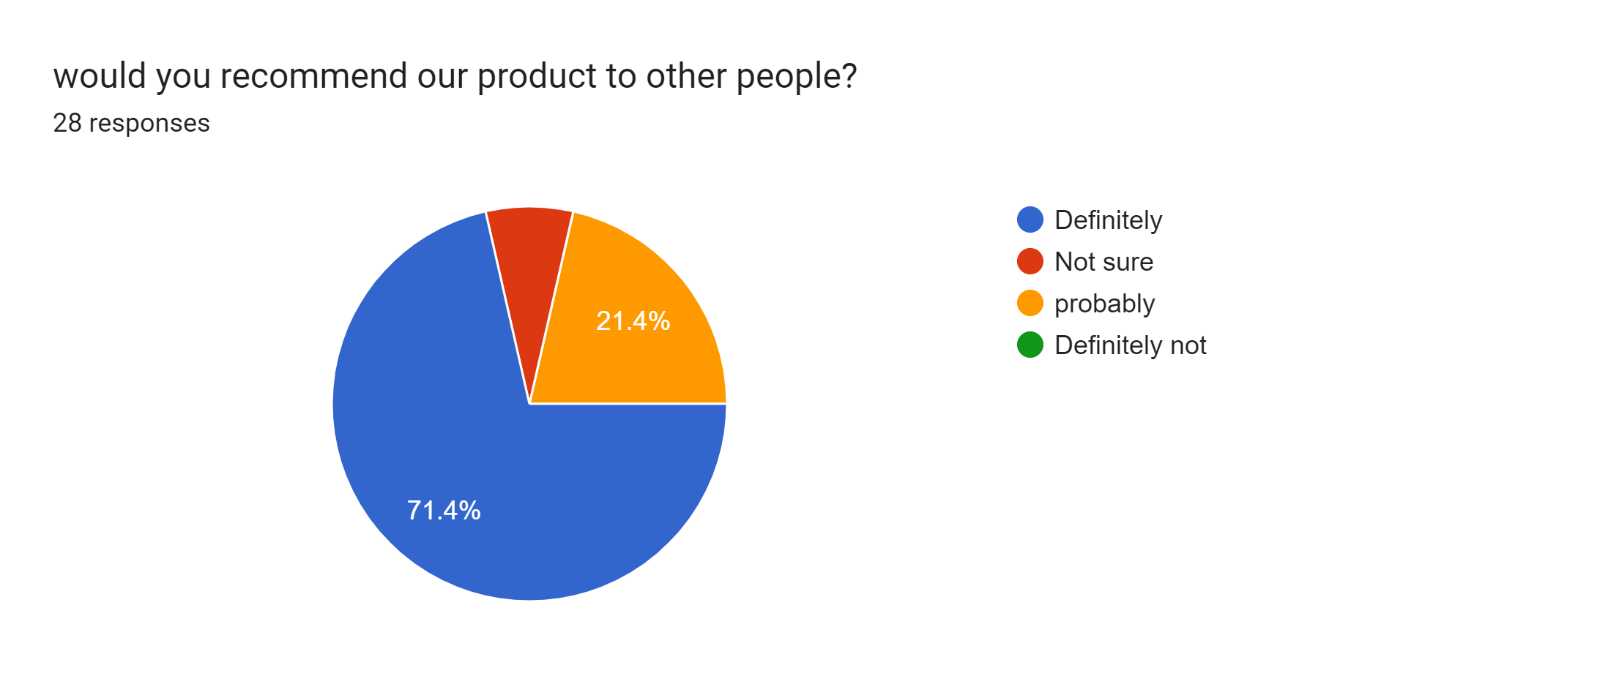

**Here's a comprehensive report with 10 bullet points on the topic of "Would you recommend our product to other people?" based on the provided data:**

1. A significant majority of respondents, specifically 71.4%, expressed a strong inclination to "Definitely recommend" your product to others. This indicates a high level of satisfaction and a willingness to endorse your product.

2. An additional 21.4% of respondents fell into the category of "Probably recommend," suggesting a substantial portion of potential advocates who are likely to spread positive word-of-mouth.

3. There is a smaller group, 7.1% of respondents, who are "Not sure" about recommending the product. This group may need more information or reassurance to become advocates.

4. The data emphasizes the positive sentiment among the majority of respondents, who are eager to promote your product to others.

5. The "Probably recommend" category represents another significant segment of potential advocates who may need a little nudge to become enthusiastic promoters.

6. Addressing the concerns or uncertainties of the "Not sure" group can help convert them into confident advocates for your product.

7. While the data provides insights into those who would recommend, it doesn't specify the percentage of those who would definitely not recommend. Identifying the reasons behind negative sentiment can be equally important.

8. Encouraging recommendations can be a powerful marketing tool, as satisfied customers often influence the buying decisions of others.

9. Brands should consider strategies to nurture and leverage their pool of potential advocates to expand their customer base.

10. In conclusion, this data highlights the strong potential for positive word-of-mouth marketing and the importance of cultivating a base of satisfied customers who are eager to recommend your product to others.

**CONCLUSION**

**Based on the provided survey data, the following key conclusions can be drawn:**

1. **Demographic Insights**: The survey captures a range of age groups among respondents, with the majority falling in the 18 to 19-year-old category. However, there is representation across different age groups, providing a diverse perspective.

2. **Product Usage Patterns**: The data indicates that a significant portion of respondents have been using the "Garnier Face Wash" for a duration of 1 to 12 months. The second most common usage duration is less than a month. This suggests a mix of both new and relatively long-standing users.

3. **Future Usage Intentions**: The majority of respondents express a strong intent to continue using the product in the future, with a significant percentage indicating they would "definitely use" it again. This highlights a positive outlook among users regarding the product's future utility.

4. **Frequency of Product Use**: A considerable percentage of respondents reported using the product once a week, indicating a high frequency of usage. This is followed by those who use it two to five times a month and once a month, demonstrating varied usage patterns.

5. **Satisfaction Levels**: A substantial proportion of respondents expressed satisfaction with the product, with the majority being "Very satisfied" and a significant portion being "Only satisfied." However, a small percentage indicated "Neutral" or "Unsatisfied" sentiments, suggesting room for improvement and the need for addressing concerns.

6. **Loyalty Drivers**: The primary driver of brand loyalty among respondents is "Quality," with a significant majority citing it as the most important factor. "Service" also plays a role in fostering loyalty. Interestingly, there is no indication that "Price" significantly influences loyalty for this group.

7. **Brand Switching Behavior**: The data reveals that a notable portion of respondents has switched from one brand product to another at some point. However, a significant percentage has remained loyal to a specific brand, indicating a range of consumer behaviors.

8. **Impressions of the Product**: Respondents were most impressed by the "Quality" of the product, followed by "Price." "Customer Service" and "Shopping Experience" were of relatively lower importance in forming impressions.

9. **Recommendation Behavior**: The majority of respondents expressed a strong willingness to recommend the product to others, with a significant percentage indicating they would "definitely recommend" it. This suggests a potential for positive word-of-mouth marketing.

10. **Room for Improvement**: While the data reflects positive sentiments overall, there are pockets of respondents who are either unsure or express dissatisfaction. Addressing the concerns of these segments and continuously improving product quality and customer service can enhance overall customer satisfaction and loyalty.

In summary, the survey provides valuable insights into consumer behavior and perceptions regarding the "Garnier Face Wash" product. It highlights the importance of product quality, user satisfaction, and the potential for brand advocacy. It also emphasizes the need to cater to varying customer needs and preferences to maintain and expand the user base.